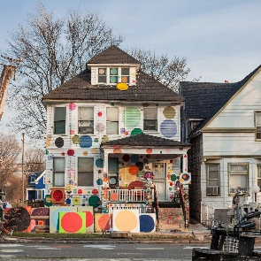
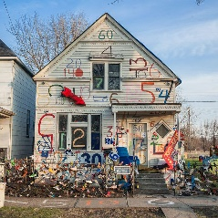
Art Challenge 1: Color My Neighborhood
Watch video clip about Detroit-based artist Tyree Guyton
https://www.youtube.com/watch?v=vnUXEU8ClSc
Your Challenge: Design and draw your dream neighborhood. What would the houses look like? Are they colorful? Do the houses have designs on them?
Extension Activity: Read story Magic Trash https://www.youtube.com/watch?v=LkEx1AevGsA
*Don’t forget to take a picture of your art and upload to Artsonia

